Development Specifications Document (DSD)

*Process Name: HealthCare Daily Appointment*

Table of Contents

**Document Overview** **1**

Automated Master Project Details **1**

Runtime Guide **1**

Runtime Diagram 1

List of Packages 2

Master Project Runtime Details 2

**Project Details** **3**

Project Name: HealthCare Daily Appointment 3

Workflow(s) specific to the Project 4

**Compliance Considerations and Reporting Requirements** **5**

**Other Details** **6**

Future Improvements 6

Debugging Tips 6

Other Remarks 6

**Post UAT Specifications** **6**

**Glossary** **6**

Version Control

|  |  |  |  |  |  |  |
| --- | --- | --- | --- | --- | --- | --- |
| Date | Version | Role | Name | Organization Department | Function | Comments |

|  |  |  |  |  |  |  |
| --- | --- | --- | --- | --- | --- | --- |
| 12/23/2020 | 1.0.4 | Author | Mohamed Mohsen | Uipath | RPA developer | Sort appointments for patients |



# Document Overview

The Development Specifications Document (DSD) is created for every business process automated using RPA. The DSD needs to be reviewed and updated for every change requested and applied to the automated process. This document provides a technical snapshot and must always reflect the latest design and key features of the automated workflow.

The document naming convention will follow the naming convention and the version of the automated process. This can be “business process name version” or it can be defined, case by case, as part of the larger RPA project design.

This document is completed by the RPA Solution architect and RPA developer who automates the business process. It is reviewed by the business process owner, application owner, and CoE design authority.

This document is meant to assist the RPA COE, IT operations and process owners by providing a snapshot of the automated process details and components. It can also serve developers to have a quick glance at the setup, before diving into the code, to troubleshoot or update changes. The purpose of the document is to record the outcome specific to the automated master project and its subcomponents: projects, workflows, sequences etc.

# Automated Master Project Details

Details filled in by the developer reflect the actual information for the master project released for production.

|  |  |  |
| --- | --- | --- |
| # | Item | Details  Fill in with free text. If not applicable, mark the filed as "N/A". No empty fields. |
| 1 | Master Project Name and Version | HealthCare Daily Appointment V1.0.4 |
| 2 | Robot Type (attended/unattended/mix) | Unattended |
| 3 | Is Orchestrator used? (Yes/No) | Yes |
| 4 | Scalable? (Yes/No)  Can the process be run by multiple robots in parallel? | No |

# Runtime Guide

## Runtime Diagram

**Architectural Structure of the Master Project** Display the interaction between components (package / robots, Orchestrator queues, and running order).

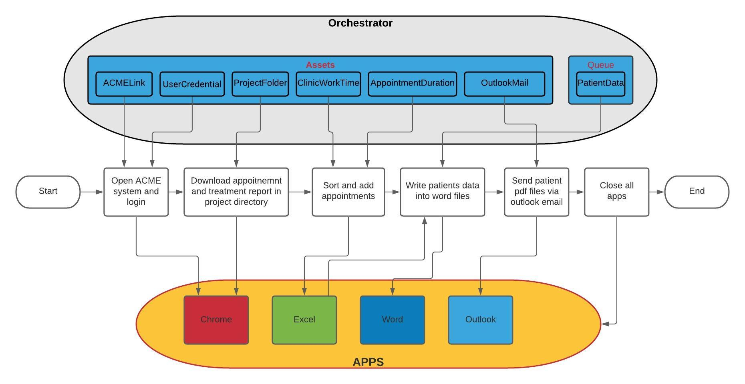

## List of Packages

Include **the list of packages and the high level description** for each of them, to explain each one's purpose:

|  |  |  |
| --- | --- | --- |
| # | Package Name | High-Level Description |
| 1 | HealthCare Daily Appointment | Get credentials from orchestrator for logging in ACME system to download today’s patients and treatment report then the robot sort the patients in excel file according to the care type they need, after that the robot create word file for every patient with his details and send it to outlook email. |
| N/A | N/A | N/A |

*Add more rows to the table to include all the project names and versions. No fields should be left empty. Use “N/A” for the items that don't apply to your project.

## Master Project Runtime Details

Details of the automated process:

|  |  |  |
| --- | --- | --- |
| # | Item | Details  (Fill in with free text. If the section does not apply to your automation, mark the field as “N/A”. No empty fields. ) |
| 1 | Production Environment Details | LAPTOP-HQAPENQM  D:\Engineering\RPA NanoDegree\Projects\CapstoneProject |
| 2 | Prerequisites to run | -**Chrome (must be installed)**  **-Excel (must be installed)**  **-Word (must be installed)**  **-Outlook (must be installed)**  -**UiRobot (must be installed)**  - **UiPath Chrome extension must be installed and enabled** |
| 3 | Input Data | Orchestrator credentials |
| 4 | Expected Output (output data) | Patients appointments and reports |
| 5 | How to start the automated process? | By the user when he needs |
| 6 | Resuming the process from a particular step | N/A |
| 7 | Reporting  queues reporting, Kibana or another platform | N/A |
| 8 | Manual Error Handling  roll back or manually complete failed transactions. Procedures to reset the item. Ex “set status as investigating” | Download files manually and give them appointment |
| 1. How to resume the process in case of error | N/A |
| 1. How to manually fix transactions with error | Download files manually and give them appointment |
| 9 | Use of Orchestrator | Yes |
| 1. Password Policies   specific compliance requests? | Secured |
| 1. Stored Credentials   Never hard code credentials in the workflow | UserCredential |
| 1. List of Asset Names | ACMELink  AppointmentDuration  ClinicWorkTime  OutlookMail  ProjectFolder |
| 1. List of Queues Name | PatientQueue |
| 1. Schedule Details | N/A |
| 10 | Recommended Resolution | N/A |

# Project Details

In this section describe all the projects that compose the automated process.

For each project, describe the workflow(s) in the logical order that they are called in.

If the workflow is a flowchart, also include the exported image from Studio.

If the automated process is composed of multiple projects, copy paste and fill in the table below for each project with its specific details (there are 2 here already, assuming a dispatcher and performer project)

## Project Name: HealthCare Daily Appointment

General information about the process selected for RPA prior to automation.

|  |  |  |
| --- | --- | --- |
| # | Item Name | Details  Fill in with free text. If not applicable, mark the field as “N/A". No empty fields. |
| 1 | Environment used for development  name, location, configuration details etc | LAPTOP-HQAPENQM  D:\Engineering\RPA NanoDegree\Projects\CapstoneProject |
| 2 | Environment prerequisites  OS details, libraries, required apps | -**Chrome (must be installed)**  **-Excel (must be installed)**  **-Word (must be installed)**  **-Outlook (must be installed)**  -**UiRobot (must be installed)**  - **UiPath Chrome extension must be installed and enabled** |
| 3 | Logging level | Error/Warn |
| 4 | Details about automation  if the apps were automated using UI Automation, Image & Text | N/A |
| 5 | In case of attended bot, can the user operate the computer while the robot is running? | Unattended robot |
| 6 | Repository for project  where the developed project is stored | N/A |
| 7 | List of reused components | OpenBrowser-Workflow  LogInACME-Workflow  GetCredentials-Workflow |
| 8 | Custom logs defined in the workflows  where Throw Activity was used or custom log message was defined | LogInACME |
| 9 | Frequent errors found in the development phase | Converting .csv to .xlsx  Wait for download .csv file  Word file editing |
| 10 | Workarounds used in the automation phase | Reindicate elements  Monitor with write line activity |
| 11 | Configuration method  assets, excel file, Json file | Assets  Excel file  Word file  Csv file  pdf file |
| 12 | Configuration details  path for input files, configuration Orchestrator assets used | Assets:  UserCredentials  ACMELink  AppointmentDuration  ClinicWorkTime  OutlookMail  ProjectFolder |
| 13 | Workflow File Export List  Use the project mapping tool | N/A |

### Workflow(s) specific to the Project

Define below all the workflow files (.xaml files) used in the project, with the Input and Output data.

|  |  |  |  |  |
| --- | --- | --- | --- | --- |
| # | Workflow File Name | Description | Arguments | Comments |
| 1 | GetCredentials | Get ACME system credentials from orchestrator | out_Password-String  out_Username-String | Add asset  “User credentials” that contains log in username and password |
| 2 | OpenApps | Opens all used apps in process. | out_ACME_URL-String  out_Apps-String[] | Add asset  “ACMELink” |
| 3 | LogInACME | Logs into the ACME test site and ensures the login was successful. | in_Username-String  in_Password-String  in_ACME_URL-String | Throw BRE  if the page  didn’t load  or the login  credentials  didn’t  work. |
| 4 | DownloadAppointments | Download each appointment file from the table, in the download directory then move it to a folder with today's date in the patient folders in the appointment folder in the project folder directory that has been extracted from orchestrator. | in_ACME_URL-String  out_TodayAppointments-String  out_ProjectFolderLocation-String | Add asset  “ProjectFolder” that contains the directory of the project folder location |
| 5 | DownloadTreatmentReport | Download treatment report and save it in the project directory in "Reports" folder. | in_ProjectFolderLocation-String  in_ACME_URL-String |  |
| 6 | SortAppointments | Sort all the patients appointments in one excel file according to the care type they need and update the social number of every patient to a queue. | in_TodayAppointments-String  out_TodayAppointmentsSheet-String  in_ProjectFolderLocation-String | Appointments must be sorted depending on the care type.  1-Urgent  2-Emergency  3-Routine |
| 7 | AppointmentTime | Give appointment time for each patient according to the clinic start work time and the duration for each appointment. | in_TodayAppointmentsSheet-String | Add assets  “ClinicWorkTime” that is the starting time of the clinic ex,12:00 PM  “AppointmentDuration” that is the duration of each appointment |
| 8 | TimeManipulation | In this workflow the robot assign the start and end of each appointment, make sure that appointments follow the duration time and changing of time. | in_AppointmentDuration-int32  in_DayTime-String  out_StartAppointment-String  out_EndAppointment-String |  |
| 9 | Convert(.csv)To(.xlsx) | The downloaded treatment report file is of type .csv. In this workflow we will convert it's type to .xlsx, then delete the .csv file. | in_ProjectFolder-String |  |
| 10 | PatientReport | In this process we create a reports folder with the date of the reports "\AppointmentsDate_reports" in the project directory in Reports folder. Then for each patient in queue we add his data in copied word file of the standard patients report template. Lastly, we send the pdf file to SendReport workflow and delete patient word file, keeping the pdf file. | in_ProjectFolder-String  in_TodayAppointmentsSheet-String |  |
| 11 | SendReport | Here we send a mail with subject line of the patient full name, and attachment of his PDF report file to your mail that is extracted from orchestrator asset. | in_PatientReport-String | Add asset ”OutlookMail” which is an outlook email |
| 12 | KillAllApps | This work flow takes the apps that used in the process and kills them all. | In_Apps-String[] |  |

# Compliance Considerations and Reporting Requirements

* N/A

# Other Details

## Future Improvements

* Use REF for better exception handling, so you can retry or reprocess if any exception error happened.

## Debugging Tips

* Use write line activity to monitor the extracted data

## Other Remarks

* Make sure that the ACME site is not already logged in

# Post UAT Specifications

* Average duration per transaction (varies depending on the Test environment): N/A
* Recommended number of robots for the specified volumes: 1
* Specified schedule: N/A

# Glossary

* **Master project** - the overall output of the development, containing one or multiple projects that together cover the scope of the robotic process automation.
* **Project** - a UiPath Studio project containing one or multiple workflow files. A project can be converted to a package and run independently, covering a particular scope within the master project. The project is used when defining the development and support phase of the automation.
* **Package** - the output of compiling a project. A package can be deployed on the robot machine and be executed by the robot service. Only one package can be executed at a given time by a robot. The package is used when defining the running phase of the automation
* **Workflow** - a component of the package, the workflow encapsulates a part of the project logic. The workflow can be of type: sequence, flowchart or state machine. a workflow is saved as an .xaml file inside the project folder. A workflow file can be invoked from another workflow and by default there is an initial workflow file that will run when executing the package.
* **Activity** - an action that the robot executes.
* **Sequence** - a workflow where activities are executed one after another, in a sequential order
* **Flowchart** - a workflow where activities are connected by arrows and the logic of the workflow can be easily followed in a visual manner. The flowchart can also be exported as an image from UiPath studio
* **State machine** - a more advanced way of organizing a workflow, similar to a flowchart.
* **BOR** - Back office robot
* **FOR** – Front office robot
* **Orchestrator** – Enterprise architecture server platform supporting: release management, centralized logging, reporting, auditing and monitoring tools, remote control, centralized scheduling, queue/robot workload management, assets management.